To get images in correct .nii.gz orientation for David’s script (DO NOT USE if using FreeSurfer!):
- File > Import DICOM
- Add Files
- Select all DICOM files in folder, click Open
- In middle box, find file with 256x256, 208 slices. Select it, and click Import.
- It opens into main BS window. Check to make sure it’s ok, then:
- File > Save Volume > Primary Volume
- Name file: XXXXHDMPRAGE.nii.gz, click Save.
  - This filename should probably be changed to XXXXHD.nii.gz before running the script on it. The MPRAGE distinction is helpful in the raw data stage, when there are multiple types of runs to deal with.
To extract the brain (edit the mask):
- File > Open Volume > select the base volume (I’ve given you a handful of them in .nii.gz format)
- You should see 3 images: 1 in each of the axial, coronal, and saggital planes
- Cortex > Skull Stripping (BSE). This will pop up a small window. You should edit this in the following way: Diffusion Iterations: 3, Diffusion Constant: 25.000000, Edge Constant: 0.60000. Make sure “remove brainstem” and “dilate final mask” are clicked as well. Press Apply (at top! NOT BFC at bottom).
- In the main window, you will see the extraction mask (a green line around the cortex). If it’s really messy, you can try altering the parameters above (I find that the Edge Constant is easiest to mess with; going to 0.750000, for example, will make the mask more conservative (less brain included), whereas going to 0.500000 will make it less conservative (more brain and possibly skull, etc., included)). If you’re altering, make sure you click the Back button all the way to the beginning before you start (4 clicks). Mess with all the parameters until you find the right mix (aka, the mask that includes the most brain without including skull; 10 minutes spent doing this could save you an hour in terms of editing). Below is a picture of a mask (and the parameters) that has been messed with until it looked good enough to work with. Note that the “dilate final mask” option is unclicked. Sometimes this helps. You can also try zooming in on the masks as you’re generating them, and scrolling through the various planes to see how much brain they’re actually including. Once you’ve picked the best extraction mask, move to the next step.
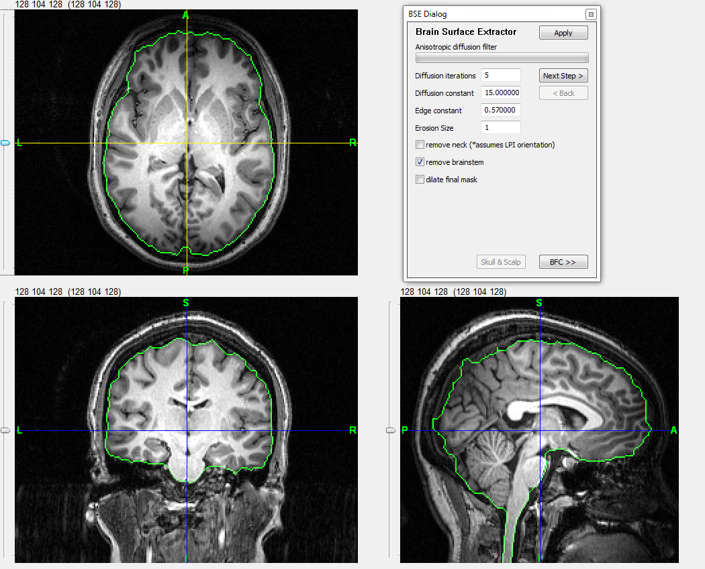

- To edit this mask, go to: Tools > Mask Tool. This will pop up another window.
- In the mask tool window, click Edit Mask.
- In the main window, you will see a small blueish ball in the center of the crosshairs (in one plane). You will want to work in the coronal plane (bottom left), moving from front to back in the brain. Keep track of the numbers at the top of that image (the coronal plane is represented by the middle set of numbers); they represent the slices. Work slice by slice front to back, then move to the next plane to check that all brain has been included, and then finally to the last plane. The checking of the other planes should go quickly, and this way you’ll have the most cohesive extraction.
- To edit to include more brain, press the left mouse button while holding down the ctrl key on the keyboard.
- To edit to include less brain, press the right mouse button while holding down the ctrl key on the keyboard.
- Some notes on editing:
- Editing the coronal plane first will yield the best results.
- Don’t be tempted to edit in the other planes while you’re working on the coronal – this will only mess up your slices.
- Zoom in really close and change up the brightness of the image – this will help you see better, particularly at the front and back of the brain. You can zoom in using the +/- circles at the top of the screen in the toolbar (next to the mask symbols). You can change the brightness of the image using the gui found at Tools > Volume Display Properties. Make sure ‘show’ is clicked under volume, then simply use the arrow to scroll down. Leave the window open – otherwise you’ll need to enter the number 429 (or whatever the brain started at) into the box under ‘show’ to get back to where you were. Please see image below to show zoomed-in brain and the volume display properties.
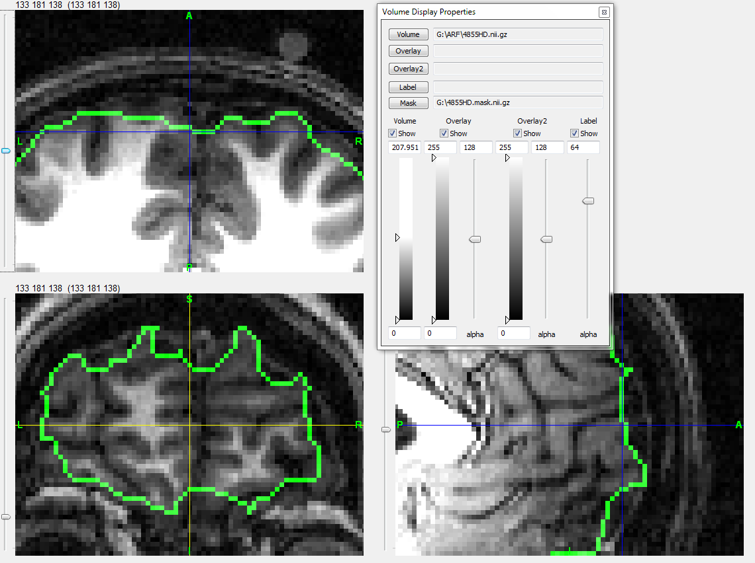
- Move through the coronal slices from front to back, but come back to the cerebellum. Doing this will allow you to zoom in more on the cerebral cortex, then you can zoom in more on the cerebellum on your return (see images below, zooming is centered in each on the appropriate part).
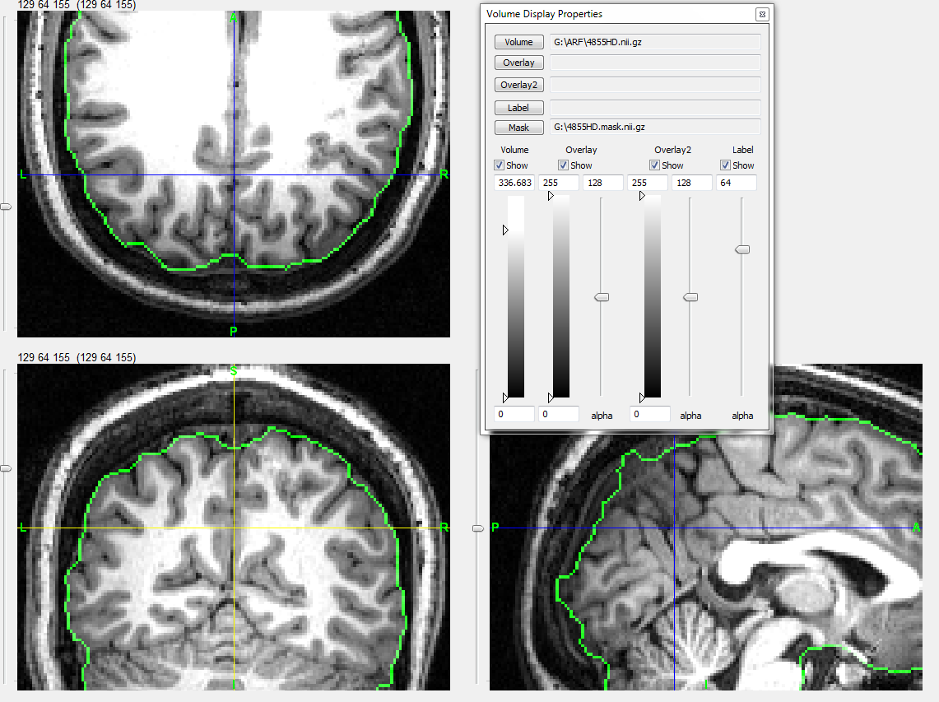
Coronal window is centered on the cerebral cortex (cerebellum is cut off).
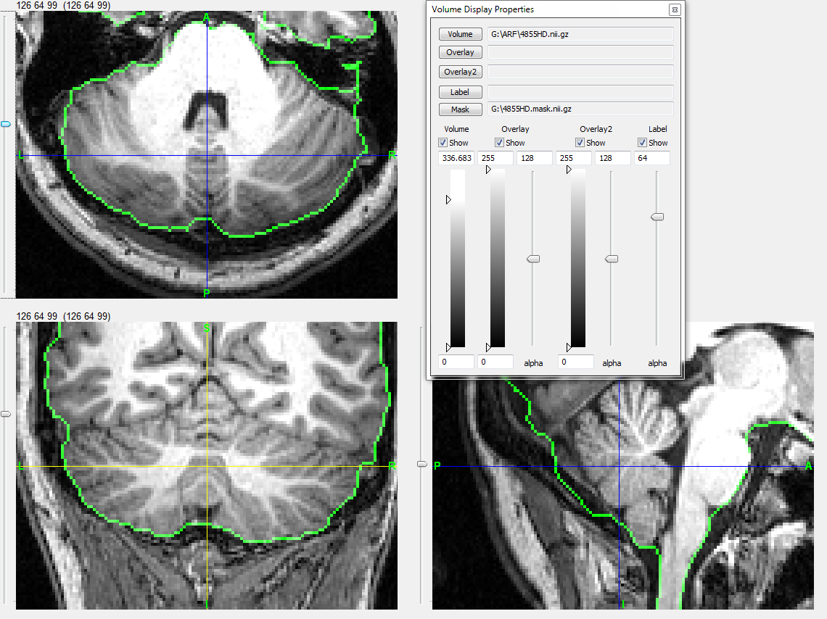
Coronal window is centered on the cerebellum (cerebral cortex is cut off).
- If you think something isn’t brain, don’t include it. That said, if you realize a few slices later that it actually was brain, go back and include it. Our main concern here is the inclusion of all brain material, and less so the exclusion of other stuff (meninges, etc).
- Don’t worry too much about the jagged edges in other planes – this will happen. As long as all the brain matter is there, you’re good.
- When you’re confident that the mask is finished (or need me to check it), go to the mask tool window, click Save Mask, and save it as ****HD.mask.nii.gz (the *s being the subject number).
To run David’s script (qcortical11aMM.dws.sh – or whatever you’ve saved it as):
- Transfer files to the mac (where the BS mac distribution has been pre-loaded), brainsuite folder.
  - Files needed for this process: the base mprage file (2000HD.nii.gz), the edited extraction mask file (2000HD.mask.nii.gz), and the bse file, generated by clicking apply mask in the mask tools window, then saving as a primary volume, as in step 6, above (2000HD.bse.nii.gz).
- Adjust the BSPATH accordingly (for my mac, it’s: /Users/MintJulep/Desktop/brainsuite)
- After editing, open terminal window, type chmod a+x qcortical3.sh
- Run script, using filenames as the argument: ./qcortical11a.dws.sh 2000HD.nii.gz
- Transfer completed files back to the desktop
To work with the surfaces:
- Load both midcortex.dfs files (right and left hemis), and both pial surface files.
- Right click, choose the surface view properties option, unselect ‘show volume slices’(this removes the volumes from the surface). If any of the surfaces are still brightly colored, select the surface you’re working within the left window (of the surface view properties window), then select ‘solid color’ (instead of vertex color). This should recolor the surface gray.
- To view one surface at a time, select the surface(s) you don’t wish to work with, and unselect ‘show’. This will leave only the surface you want to see. To toggle between surfaces, select the secondary surface, then select and unselect ‘show’ at will.
To mark sulci:
- With the midcortex surface (either right or left hemi) preloaded, right click anywhere on the surface, and select Tools > Curve protocol tool.
- Within the curve protocol tool window, select Load Protocol, and choose the appropriate protocol file (I use Hanna’s LONI 2000 protocol, saved on my desktop so it’s easy to quickly locate).
- Select the first curve in the curve list (often central sulcus).
- Follow the start and stop points delineated in the protocol exactly. These points make or break the sulcal lining-up in the labeling process later. If more description is needed, view the full protocol PDF (Sulci-tracing_protocol_on-white_3-8-08.pdf).
- To mark the curve: hold down shift while clicking the left mouse button.
- Press clear segment (in the curve protocol tool) to clear the last part of the curve marked; press clear curve to clear the entire curve, including the initial starting point. Press clear all to clear all curves.
- To adjust the end of a segment, hold down alt and the left mouse button; move the curve until pleased.
- Press the z key to remove the surface in quarters.
- Save files as ****HD.*.dfc (example: 2000HD.RHemi.dfc). Remember to trace on one hemi at a time.

